Halls Crossroads Historical Museum
Statement of Mission
The Halls Crossroads Historical Museum seeks to preserve the history of the community by collecting and displaying documents and artifacts for use by current and future generations.

Dear Patron:
The Board of Directors of the Halls Crossroads Historical Museum is committed to founding a museum that will preserve the rich history of the community. Establishing the museum ensures that future generations will recall with pride the founding fathers of the community and their vision for the future.
Thank you for your interest and support as we embark on this exciting journey.
Officers and Board of Directors, Halls Crossroads Historical Museum

This form may be used to make a donation or to apply for membership.
Membership information is below. Donation information is on the reverse side.

MEMBERSHIPS:
Types of Membership | Amount | Duration | Benefits
Hubert LaRue | $10,000 | Lifetime  (1 time gift) | Lifetime membership for one person and guests. Recognition on plaque in museum. Invitation to special events and quarterly meetings.
Charter | $5,000 | Lifetime  (1 time gift) | Lifetime membership for one person and guests. Recognition on plaque in museum. Invitation to special events and quarterly meetings.
Corporate | $500 | Annual | Membership for one person and guests for one year. Invitation to special events and quarterly meetings.
Crossroads/ Family | $100 | Annual | Membership for one person and guests for one year. Invitation to special events and quarterly meetings.
Friend | $25 | Annual | Membership for person for one year. Invitation to special events and quarterly meetings.
Membership cards will be issued with a unique number for each member.
Annual memberships are 12-months beginning in January.

Detach here and mail completed form and check for the Total Amount to: HCHM, P.O. Box 71043, Knoxville, TN 37938

Name _______________________________________________________________________________
Address _______________________________________________________________________________
^{Street} ^{City} ^{State} ^{Zip}
Email ____________________________________ Telephone _________________________________
Type of Membership/Amount: Lifetime Hubert Larue $____________ Lifetime Charter $_____________
Annual: Corporate $___________Crossroads/Family $___________ Friend $_____________
Membership (this page) $___________
Donations (from reverse) $___________
TOTAL ENCLOSED: $___________

THANK YOU FOR YOUR SUPPORT. WE ARE A 501c3 ORGANIZATION.
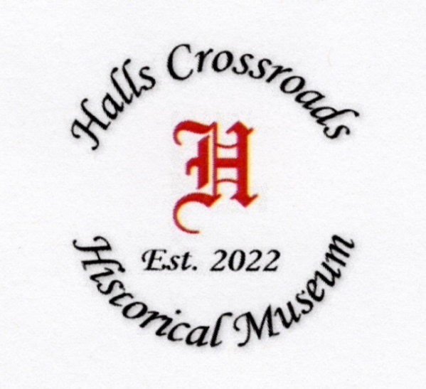

Halls Crossroads
Historical Museum

Officers
President Carol Bayless
Vice President Doris Smith
Secretary Terri Carr
Treasurer Lisa Goins
Parliamentarian Shelba Murphy

Board of Directors
Kathy Breeden
Mary Carroll
Lisa Goins
Brenda Gratz
Susie LaRue
Gordy Noe
Cathy Robinson
Carl Tindell
Chris Vandergriff
Gilbert Watson

PRESERVING HISTORY
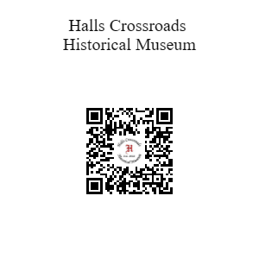

DONATIONS

DONOR: _________________________________________________ _____________________________________________
^{Name} ^{Street} ^{City} ^{State} ^{Zip}
^{GENERAL DONATION:} AMOUNT $____________________
IN HONOR OF: ________________________________ AMOUNT: $_________________

HONOREE ADDRESS ____________________________________________________________________________
^{Street} ^{City} ^{State} ^{Zip}
(Acknowledgment card will be mailed to honoree.)
Membership Application
& Donation Form

LOCATION
Birch Tree Plaza
7119 Afton Drive, Suite 101
Knoxville, TN 37918

Mailing Address
P.O. Box 71043
Knoxville, TN 37938

E-mail: HCHMUSEUM2@GMAII.COM
Website: WWW.HCHMMUSEUM.ORG
Facebook:
https://www.facebook.com/halls
crossroads historical museum

A non-profit organization

Donations:
You may make 2 types of donations: A general donation to support our museum or a donation In Honor Of an individual

